**LAB - 4**

**SIMPLE CBIVR SYSTEM**

**PRIYANSHU SHARMA**

**15BCE1282**

**Implement a CBIVR system that uses the following image descriptor**

1. **Image Dimension**
2. **Color mean of R, G, B color channels**
3. **Standard deviation of R, G, B color channels**

**CODE -**

**ANSWER - 1**

clc

clear all

q=imread('C:\Users\PRIYANSHU SHARMA\Desktop\PRIYANSHU\6 STUDY\MATLAB\LAB 4\1.jpg');

%size of query image

[x y z]=size(q);

total=x*y

%%DATABASE

fr=[];

srcFiles = dir('C:\Users\PRIYANSHU SHARMA\Desktop\PRIYANSHU\6 STUDY\MATLAB\LAB 4\*.jpg');

srcFiles;

for i=2:10

d = strcat('C:\Users\PRIYANSHU SHARMA\Desktop\PRIYANSHU\6 STUDY\MATLAB\LAB 4\',srcFiles(i).name);

di = imread(d);

%size of database image

[xd yd zd]=size(di);

totald=xd*yd

fr(i)=abs(total-totald);

end

ra=[];

fr(1)=[];

ascen=sort(fr);

[m, n]=size(fr);

k=1;

while(k<n+1)

%%k

ex=[];

ex=find(fr==ascen(k));

%ex

[q, w]=size(ex);

%%w

if(w>1)

for j=1:w

%%ex(j)

ra(k)=ex(j);

k=k+1;

%%k

end

k=k-1;

elseif(w==1)

ra(k)=ex;

end

k=k+1;

end

fr

ascen

ra

for i=1:9

name = strcat(num2str(ra(i)),'.jpg');

filename = strcat('C:\Users\PRIYANSHU SHARMA\Desktop\PRIYANSHU\6 STUDY\MATLAB\LAB 4\',name);

result = imread(filename);

figure;

image(result);

end

**RESULT**

total = 50325

totald = 50325

totald = 50400

totald = 50508

totald = 50320

totald = 50416

totald = 50325

totald = 50246

totald = 50424

totald = 50424

fr = 0 75 183 5 91 0 79 99 99

ascen = 0 0 5 75 79 91 99 99 183

ra = 1 6 4 2 7 5 8 9 3

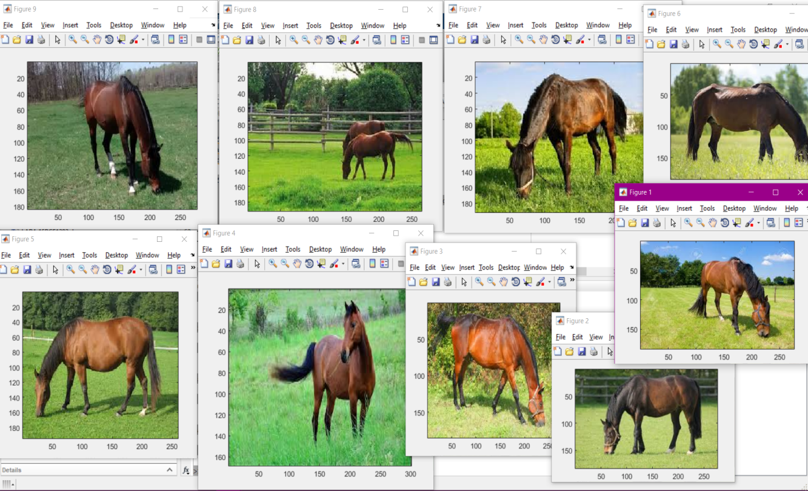

ALL THE RESULTANT IMAGES ARE RETRIEVE FROM THE IMAGE DATABASE

**ANSWER - 2**

clc

clear all

q=imread('C:\Users\PRIYANSHU SHARMA\Desktop\PRIYANSHU\6 STUDY\MATLAB\LAB 4\1.jpg');

%Creating channels

redChannel = q(:, :, 1);

greenChannel = q(:, :, 2);

blueChannel = q(:, :, 3);

z = zeros(size(q), class(q));

redImage = z; redImage(:,:,1) = redChannel;

greenImage = z; greenImage(:,:,2) = greenChannel;

blueImage = z; blueImage(:,:,3) = blueChannel;

%Get histValues for each channel

[yRed, x] = imhist(redChannel);

[yGreen, x] = imhist(greenChannel);

[yBlue, x] = imhist(blueChannel);

%Getting the hist values

r = imhist(redChannel,32);

g = imhist(greenChannel,32);

b = imhist(blueChannel,32);

%Plot them together in one plot

figure, plot(x, yRed, 'Red', x, yGreen, 'Green', x, yBlue, 'Blue');

%mean

R=mean(r)

G=mean(g)

B=mean(b)

%%DATABASE

fr=[];

srcFiles = dir('C:\Users\PRIYANSHU SHARMA\Desktop\PRIYANSHU\6 STUDY\MATLAB\LAB 4\*.jpg');

srcFiles;

for i=2:10

d = strcat('C:\Users\PRIYANSHU SHARMA\Desktop\PRIYANSHU\6 STUDY\MATLAB\LAB 4\',srcFiles(i).name);

di = imread(d);

%%Creating Channels

redChannels = di(:, :, 1);

greenChannels = di(:, :, 2);

blueChannels = di(:, :, 3);

zd = zeros(size(di), class(di));

redImaged = zd; redImaged(:,:,1) = redChannels;

greenImaged = zd; greenImaged(:,:,2) = greenChannels;

blueImaged = zd; blueImaged(:,:,3) = blueChannels;

%Getting the hist values

rd = imhist(redChannels,32);

gd = imhist(greenChannels,32);

bd = imhist(blueChannels,32);

%mean

Rd=mean(rd);

Gd=mean(gd);

Bd=mean(bd);

fr(i)=abs(R-Rd);

end

ra=[];

fr(1)=[];

ascen=sort(fr);

[m, n]=size(fr);

k=1;

while(k<n+1)

%%k

ex=[];

ex=find(fr==ascen(k));

%ex

[q, w]=size(ex);

%%w

if(w>1)

for j=1:w

%%ex(j)

ra(k)=ex(j);

k=k+1;

%%k

end

k=k-1;

elseif(w==1)

ra(k)=ex;

end

k=k+1;

end

fr

ascen

ra

for i=1:9

name = strcat(num2str(ra(i)),'.jpg');

filename = strcat('C:\Users\PRIYANSHU SHARMA\Desktop\PRIYANSHU\6 STUDY\MATLAB\LAB 4\',name);

result = imread(filename);

figure;

image(result);

end

**RESULT**

R = 1.5727e+03

G = 1.5727e+03

B = 1.5727e+03

fr = 0 2.3438 5.7188 0.1563 2.8438 0 2.4688 3.0938 3.0938

ascen = 0 0 0.1563 2.3438 2.4688 2.8438 3.0938 3.0938 5.7188

ra = 1 6 4 2 7 5 8 9 3

**HISTOGRAM OF ALL THE THREE COLOR CHANNELS**

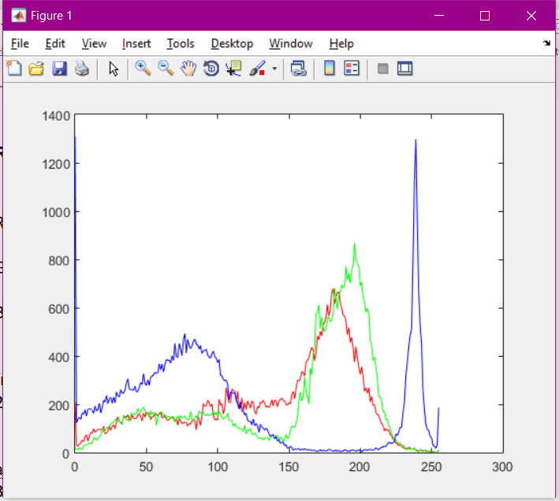

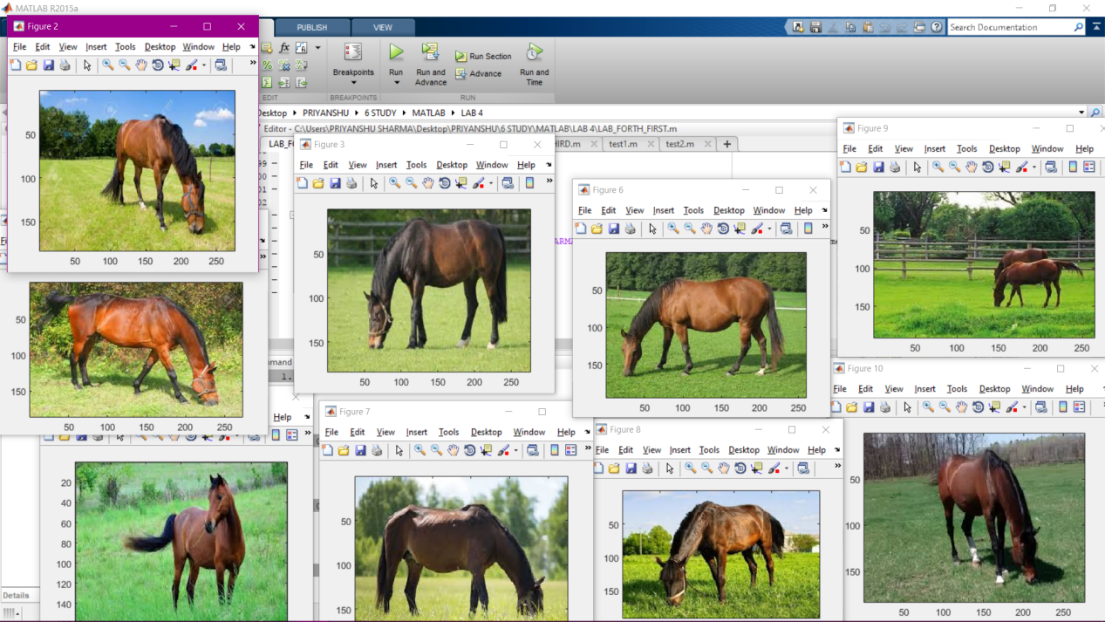

ALL THE RESULTANT IMAGES ARE RETRIEVE FROM THE IMAGE DATABASE

**ANSWER - 3**

clc

clear all

q=imread('C:\Users\PRIYANSHU SHARMA\Desktop\PRIYANSHU\6 STUDY\MATLAB\LAB 4\1.jpg');

%Creating channels

redChannel = q(:, :, 1);

greenChannel = q(:, :, 2);

blueChannel = q(:, :, 3);

z = zeros(size(q), class(q));

redImage = z; redImage(:,:,1) = redChannel;

greenImage = z; greenImage(:,:,2) = greenChannel;

blueImage = z; blueImage(:,:,3) = blueChannel;

%Get histValues for each channel

[yRed, x] = imhist(redChannel);

[yGreen, x] = imhist(greenChannel);

[yBlue, x] = imhist(blueChannel);

%Getting the hist values

r = imhist(redChannel,32);

g = imhist(greenChannel,32);

b = imhist(blueChannel,32);

%Plot them together in one plot

figure, plot(x, yRed, 'Red', x, yGreen, 'Green', x, yBlue, 'Blue');

%mean

R=std(r);

G=std(g);

B=std(b);

Z=(R+G+B)/3;

%%DATABASE

fr=[];

srcFiles = dir('C:\Users\PRIYANSHU SHARMA\Desktop\PRIYANSHU\6 STUDY\MATLAB\LAB 4\*.jpg');

srcFiles;

for i=2:10

d = strcat('C:\Users\PRIYANSHU SHARMA\Desktop\PRIYANSHU\6 STUDY\MATLAB\LAB 4\',srcFiles(i).name);

di = imread(d);

%%Creating Channels

redChannels = di(:, :, 1);

greenChannels = di(:, :, 2);

blueChannels = di(:, :, 3);

zd = zeros(size(di), class(di));

redImaged = zd; redImaged(:,:,1) = redChannels;

greenImaged = zd; greenImaged(:,:,2) = greenChannels;

blueImaged = zd; blueImaged(:,:,3) = blueChannels;

%Getting the hist values

rd = imhist(redChannels,32);

gd = imhist(greenChannels,32);

bd = imhist(blueChannels,32);

%mean

Rd=std(rd);

Gd=std(gd);

Bd=std(bd);

z=(Rd+Gd+Bd)/3;

fr(i)=abs(Z-z);

end

ra=[];

fr(1)=[];

ascen=sort(fr);

[m, n]=size(fr);

k=1;

while(k<n+1)

%%k

ex=[];

ex=find(fr==ascen(k));

%ex

[q, w]=size(ex);

%%w

if(w>1)

for j=1:w

%%ex(j)

ra(k)=ex(j);

k=k+1;

%%k

end

k=k-1;

elseif(w==1)

ra(k)=ex;

end

k=k+1;

end

fr

ascen

ra

for i=1:9

name = strcat(num2str(ra(i)),'.jpg');

filename = strcat('C:\Users\PRIYANSHU SHARMA\Desktop\PRIYANSHU\6 STUDY\MATLAB\LAB 4\',name);

result = imread(filename);

figure;

image(result);

end

**RESULT**

fr = 193.0213 379.9474 553.3730 375.3920 455.8707 387.7740 186.4446 184.4583 99.8075

ascen = 99.8075 184.4583 186.4446 193.0213 375.3920 379.9474 387.7740 455.8707 553.3730

ra = 9 8 7 1 4 2 6 5 3



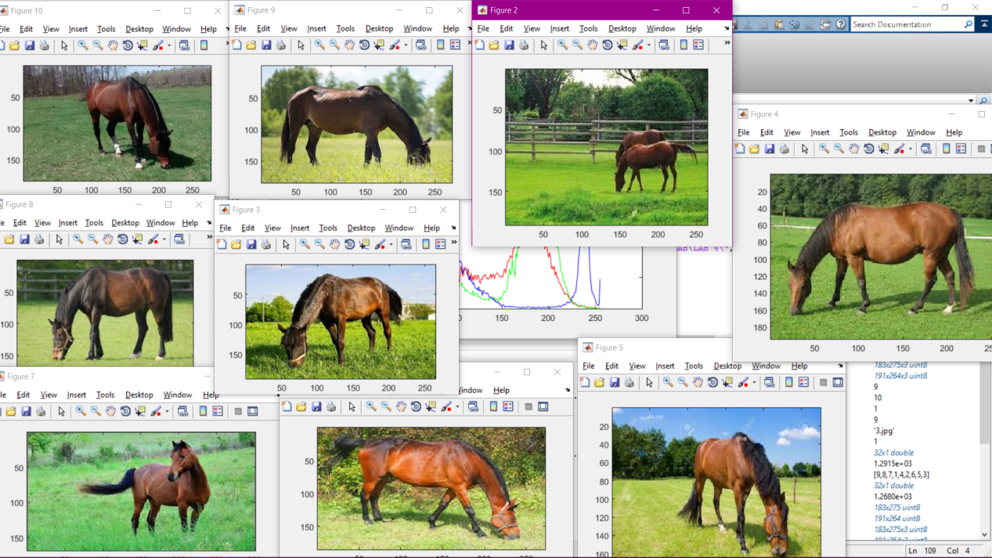

ALL THE RESULTANT IMAGES ARE RETRIEVE FROM THE IMAGE DATABASE